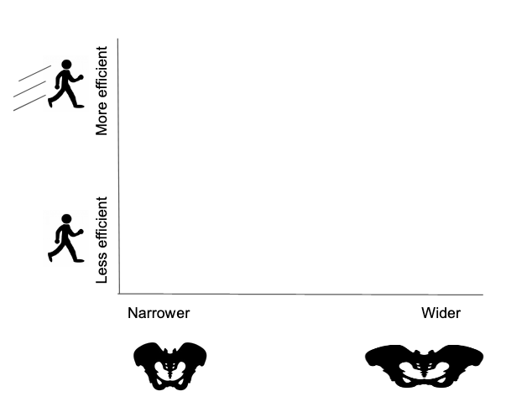

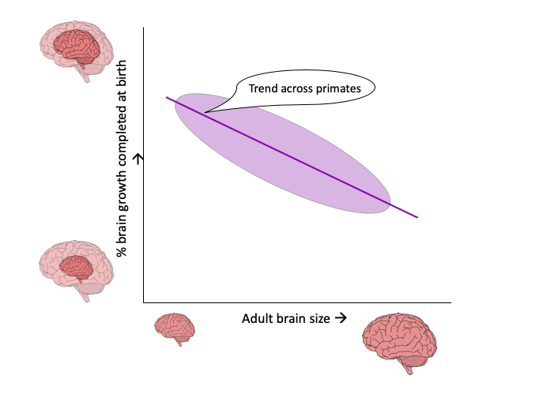

|  |  |  |  |
| --- | --- | --- | --- |
| **Prediction** | **Figure** | **Interpretation** | **Prediction supported?** |
| **A.** |  |  |  |
| **B.** |  |  |  |
| **C.** |  |  |  |