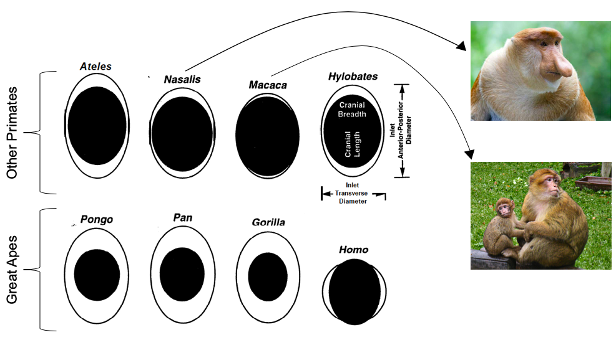
Figure 1. The relationship between the size of the maternal pelvis and the size of the infant’s head at the time of birth in eight primate species. Left to right, top row: spider monkey (Ateles), proboscis monkey (Nasalis), macaque (Macaca), and gibbon (Hylobates). Left to right, bottom row: orangutan (Pongo), chimpanzee (Pan), gorilla (Gorilla), and human (Homo).
Figure adapted from: Rosenberg & Trevathan 1995

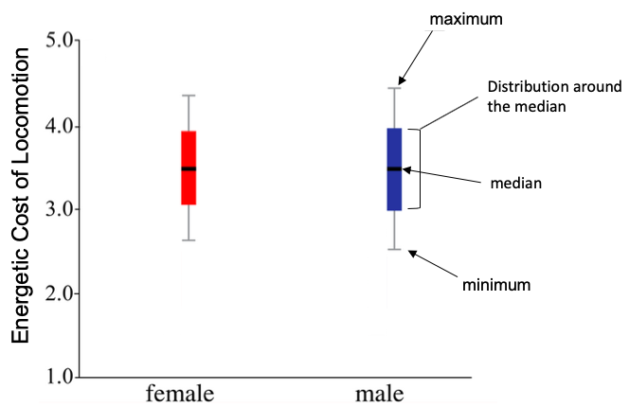
Figure 2. The energetic costs of locomotion (walking and running) in male and female humans. On average, the female pelvis is wider than the male pelvis. Information on how to interpret a box plot is included on the graph.
Figure adapted from: Warrener et al. 2015
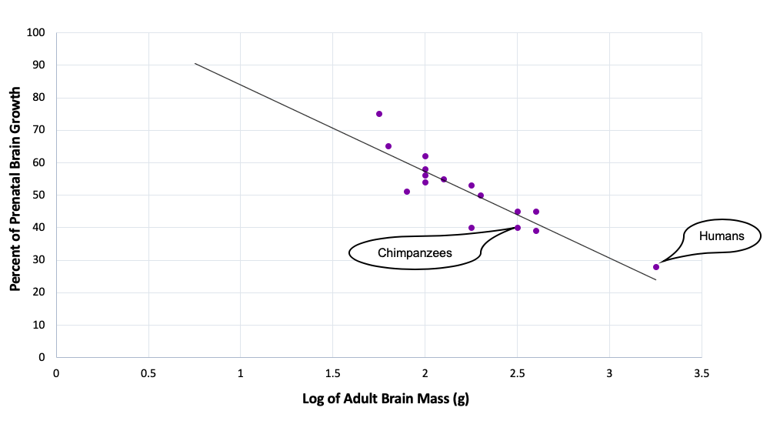
Figure 3. The relationship between adult brain mass and the percentage of brain growth that is completed prior to birth in Old World monkeys and apes. The points representing humans and chimpanzees are indicated on the graph.
Figure adapted from: DeSilva & Leskin 2008

